Project sample
Task 3.3 : Constructing Data…
Deliverable 1 : Data Attribute Report…
- Attribute name and Data Type:
df.info()
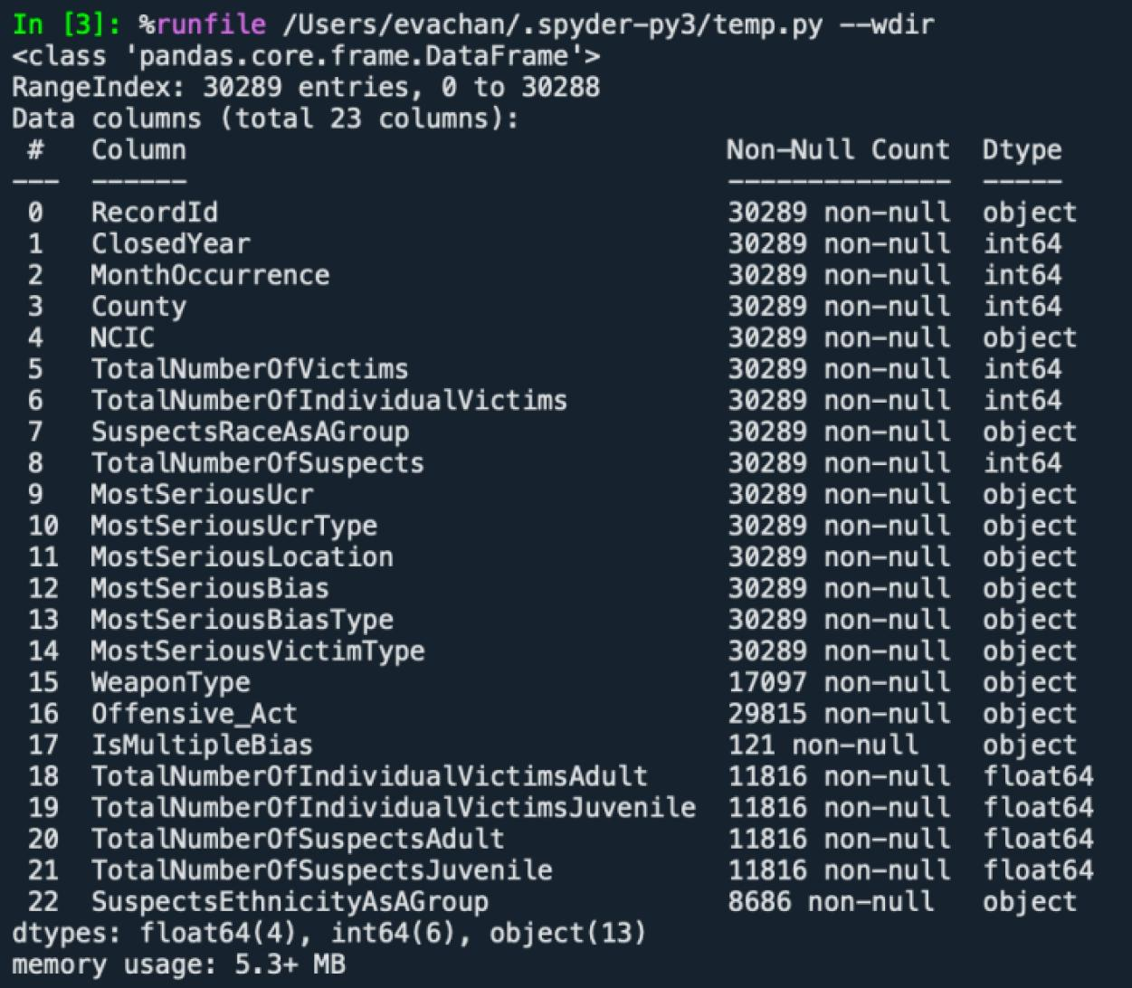

Unique Values Count – There are 57 distinct values in the attribute.
“County” column has 57 unique values.

Code:
distinct_county = df['County'].nunique()
output: 57

Missing Values Count – WeaponType has 13192 missing or NULL entries, offensive_act has 474, please see the summary below:

Code:
df.isnull().sum()
df.isnull().sum()
output:
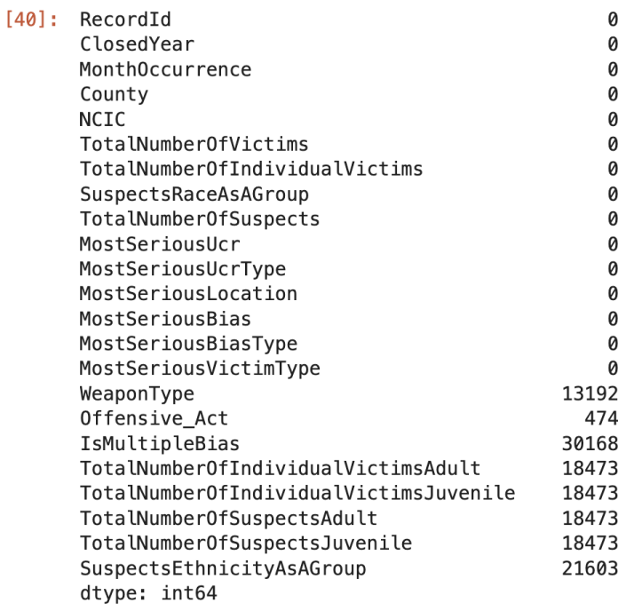

Statistical Summary (for Numeric Fields):
The following shows the mean, minimum, percentile, maximum, count, standard deviation of each attribute:

Code:
df.describe().transpose()

Output:
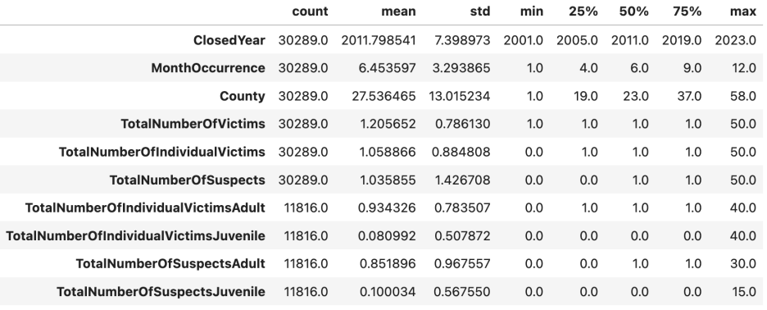

Outliers – Any extreme values that might need handling.
Code:
import pandas as pd
import matplotlib.pyplot as plt
import seaborn as sns
df = pd.read_csv(r'~/Desktop/mergeYearMonth_inner_4.csv')
numeric_columns = df.select_dtypes(include=['number']).columns
plt.figure(figsize=(12, 6))

for i, col in enumerate(numeric_columns):
plt.subplot(2, (len(numeric_columns) + 1) // 2, i + 1)
sns.boxplot(y=df[col])
plt.title(f'Boxplot for {col}')

plt.tight_layout()
plt.show()

Output:
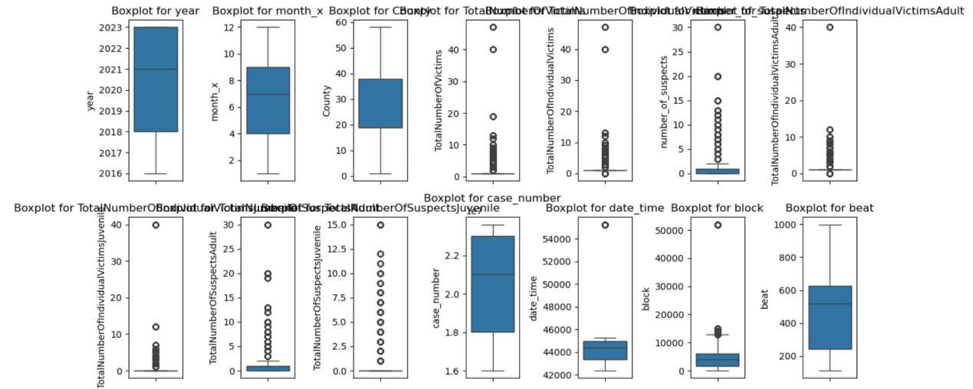

Data Quality Issues – Duplicates, inconsistencies, or invalid entries.
- Duplicates rows: there is no duplicate rows.
Code:
duplicates = df[df.duplicated()]
output:
[0 rows x 23 columns]

Check for entries with NULL or NaN:
Code:
df.isnull().sum()
nan_values = df.isna().sum()

Output:


- Check for Data Type Mismatches:
Finding: from the output we find the data type are matched.
Code:
data_types = df.dtypes

# Print columns with incorrect data types
print("\nData Types of Each Column:")
print(data_types)

# Check for numeric columns that have non-numeric values (e.g., strings in numeric columns)
numeric_columns = df.select_dtypes(include=['number']).columns
for col in numeric_columns:
if df[col].dtype != 'float64' and df[col].dtype != 'int64':
print(f"Column '{col}' contains inconsistent data types!")

output:
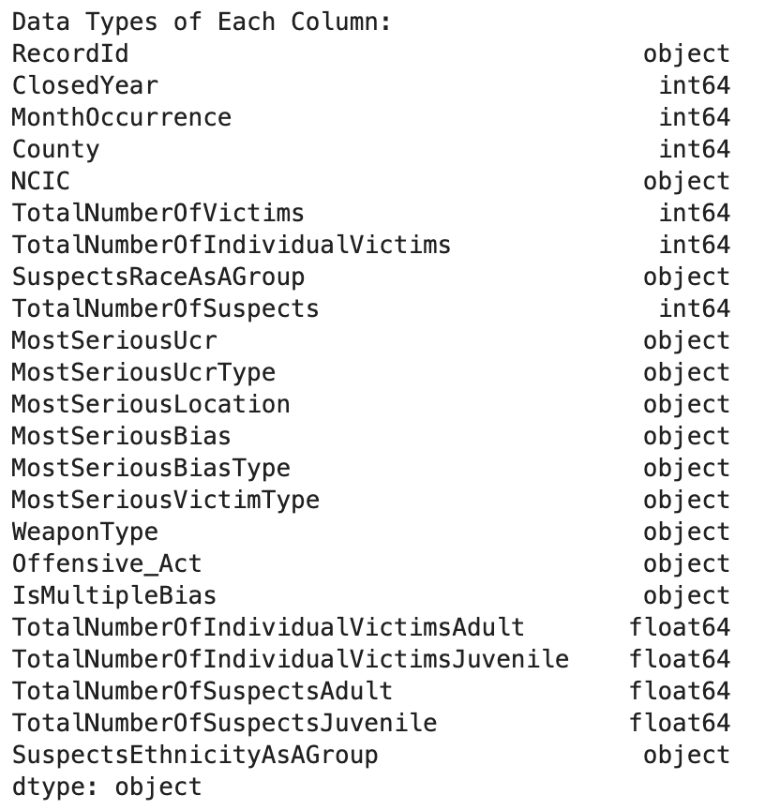

- Check for Inconsistent Formatting (e.g., text/categorical columns):
print the unique value and check for if the case is consistent, leading/trailing whitespace.

Finding: We found they are consistent in the dataset.

Code:
categorical_columns = df.select_dtypes(include=['object', 'category']).columns

# Check unique values in each categorical column
for col in categorical_columns:
unique_values = df[col].unique()
print(f"\nUnique Values in '{col}':")
print(unique_values)

output:
Unique Values in 'RecordId':
['CA01-0000000001' 'CA01-0000000002' 'CA01-0000000003' ...
'CA23-0000001227' 'CA23-0003128011' 'CA23-0004748343']

Unique Values in 'NCIC':
['100' '101' '103' '105' '107' '108' '109' '111' '112' '115' '130' '405'
'700' '701' '702' '704' '705' '706' '707' '708' '709' '710' '711' '712'
'714' '715' '718' '800' '1000' '1005' '1007' '1201' '1203' '1300' '1500'
'1502' '1506' '1700' '1702' '1900' '1902' '1903' '1905' '1906' '1908'
'1910' '1912' '1913' '1914' '1915' '1916' '1919' '191F' '191H' '191R'
'191W' '1920' '1921' '1922' '1924' '1925' '1927' '1931' '1935' '1936'
'1937' '1938' '1939' '1941' '1942' '1944' '1945' '1946' '1947' '1949'
'1950' '1952' '1953' '1954' '1955' '1956' '1959' '1960' '1961' '1962'
'1965' '1968' '1972' '1974' '1975' '1976' '1977' '1978' '1983' '1996'
'1997' '2002' '2100' '2106' '2109' '2111' '2200' '2300' '2303' '2400'
'2402' '2601' '2700' '2704' '2708' '2800' '2802' '2900' '3000' '3001'
'3002' '3003' '3004' '3005' '3006' '3007' '3008' '3009' '3010' '3011'
'3012' '3013' '3014' '3015' '3017' '3018' '3019' '3021' '3024' '3026'
'3027' '3039' '3042' '3043' '3048' '3097' '3100' '3103' '3104' '3105'
'3300' '3301' '3308' '3311' '3312' '3313' '3315' '3330' '3332' '3338'
'3400' '3401' '3404' '3408' '3414' '3600' '3601' '3602' '3603' '3604'
'3605' '3606' '3607' '3608' '3610' '3612' '3613' '3616' '3620' '3650'
'3700' '3701' '3702' '3704' '3706' '3707' '3708' '3709' '3710' '3711'
'3712' '3713' '3715' '37A1' '37A2' '37A3' '37A4' '3801' '3803' '3900'
'3902' '3903' '3904' '3905' '3906' '3915' '4001' '4002' '4003' '4004'
'4005' '4006' '4019' '4100' '4104' '4105' '4109' '4111' '4113' '4114'
'4116' '4200' '4201' '4203' '4300' '4303' '4308' '4311' '4312' '4313'
'4314' '4315' '4316' '4317' '4321' '4395' '4400' '4402' '4403' '4404'
'4408' '4497' '4500' '4502' '4800' '4802' '4803' '4806' '4807' '4900'
'4903' '4904' '4905' '4908' '4915' '5000' '5001' '5002' '5004' '5005'
'5007' '5100' '5102' '5201' '5202' '5501' '5600' '5601' '5602' '5603'
'5604' '5605' '5607' '5608' '5609' '5614' '5701' '5797' '5800' '1208'
'1928' '1934' '1901' '1940' '2403' '1971' '1932' '1926' '1923' '3621'
'724' '2107' '4709' '3609' '1607' '2901' '3397' '902' '4007' '3797'
'3705' '5700' '4202' '3402' '192U' '4106' '1969' '2103' '402' '3035'
'4307' '4805' '3640' '500' '2113' '1207' '192H' '3611' '3342' '104'
'2500' '4901' '4306' '721' '2908' '2706' '5300' '2902' '3305' '106'
'1943' '3049' '4204' '3310' '1980' '3317' '3331' '4115' '3632' '4909'
'1602' '3623' '190P' '5703' '4117' '3032' '5704' '3630' '2406' '1013'
'5407' '3318' '3501' '1603' '3341' '192J' '717' '1984' '4120' '4813'
'1006' '197' '5801' '3200' '1933' '1990' '1929' '5003' '4008' '3325'
'497' '1917' '901' '3025' '114' '300' '1801' '102' '2001' '4101' '3314'
'4127' '1904' '3023' '3633' '190C' '5006' '1973' '400' '3703' '3497'
'4907' '2719' '1011' '404' '1401' '1097' '3897' '1400' '1012' '3816'
'5406' '3303' '4913' '403' '723' '190X' '2301' '1001' '4310' '3302' '726'
'1503' '4501' '1200' '3306' '3016' '3714' '2701' '5606' '190D' '3635'
'1017' '4902' '113' '1948' '3732' '2401' '1981' '4107' '3725' '602'
'4708' '2712' '1302' '4000' '5802' '4297' '3340' '1907' '5010' '900'
'4102' '1597' '1100' '3699' '1800' '5500' '1958' '340H' '4906' '2710'
'2703' '3614' '501' '3036' '1964' '1967' '4110' '3496' '4302' '4801'
'2711' '734' '703' '600' '3022' '4914' '4304' '37A5' '1508' '3412' '1501'
'3344' '1982' '3500' '302' '2600' '3309' '4108' '3101' '2707' '1963'
'801' '1970' '4804' '110' '2105' '121' '190R' '5401' '2000' '4205' '3901'
'1918' '4013' '2104' '1301' '5405' '3805' '716' '1509' '4706' '1951'
'3377' '5408' '5403' '4211' '1507' '1966' '5622' '4327' '3455' '1015'
'1101' '1004' '407' '5400' '2108' '3379' '33A0' '4123' '4401' '2404'
'5009' '200' '3299' '1600' '3659' '3641' '1601' '1305' '3378' '2117'
'5008' '3631' '3799' '601' '4212' '4214' '1002' '190K' '1003' '1909'
'4103' '1306' '5680' '1008' '3622' '3420' '4210' '2803' '1701' '4014'
'2114' '2809' '3047' '2405' '4911' '2110' '4305' '1606' '1009' '1304'
'3020' '2709' '2702' '5412' '1521' '3499' '1204' '3454' '2808' '19A9'
'1205' '3657' '740' '5200' '1499' '3626' '3399' '3924' '5411' '303'
'3349' '1511' '1505' '1512' '19A8' '3728' '4700' '2199' '2801' '4119']

Unique Values in 'SuspectsRaceAsAGroup':
['White' 'Black or African American' 'Unknown' 'Group of Multiple Races'
'Asian/Pacific Islander' 'American Indian or Alaska Native' 'Hispanic'
'East Indian' 'East Indian/Asian Indian' 'Asian'
'Native Hawaiian or Other Pacific Islander']

Unique Values in 'MostSeriousUcr':
['Simple Assault' 'Intimidation' 'Destruction/Damage/Vandalism' 'Arson'
'Aggravated Assault' 'Burglary' 'Robbery' 'Larceny-Theft' 'Murder' 'Rape'
'Motor Vehicle Theft' 'False Pretense/Swindle/Confidence Game' 'Fondling'
'Weapons Law Violations' 'Kidnapping/Abduction'
'Hacking/Computer Invasion' 'Impersonation' 'Counterfeiting/Forgery'
'Pornography/Obscene Material' 'Drug/Narcotic Violations'
'Extortion/Blackmail' 'Drug Equipment Violations' 'Sodomy']

Unique Values in 'MostSeriousUcrType':
['Violent Crimes' 'Property Crimes' 'Society Crimes']

Unique Values in 'MostSeriousLocation':
['Bar/Night Club' 'Residence/Home/Driveway' 'Convenience Store'
'School/college' 'Parking Lot/Garage' 'Church/Synagogue/Temple'
'Highway/Road/Alley/Street' 'Restaurant' 'Liquor Store'
'Grocery/Supermarket' 'Service/Gas Station' 'Department/Discount Store'
'Commercial/Office Building' 'Specialty Store (TV/Fur/etc.)'
'Field/Woods/Park' 'Government/Public Building' 'Construction Site'
'Hotel/Motel/etc.' 'Air/Bus/Train Terminal' 'Jail/Prison'
'Drug Store/Dr Office/Hospital' 'Bank/Savings and Loan'
'Rental Storage Facility' 'Lake/Waterway/Beach' 'Other/Unknown'
'School-College/University' 'School-Elementary/Secondary' 'Shopping Mall'
'Park/Playground' 'Farm Facility' 'Amusement Park'
'Gambling Facility/Casino/Race Track' 'Abandoned/Condemned Structure'
'Camp/Campground' 'Shelter-Mission/Homeless' 'Industrial Site'
'Rest Area' 'Dock/Wharf/Freight/Modal Terminal' 'Daycare Facility'
'Tribal Lands' 'Community Center' 'Arena/Stadium/Fairgrounds/Coliseum'
'ATM Separate from Bank' 'Auto Dealership New/Used' 'Hotel/Motel/Etc.'
'Cyberspace']

Unique Values in 'MostSeriousBias':
['Anti-Black or African American' 'Anti-Hispanic or Latino'
'Anti-Other Race/Ethnicity/Ancestry' 'Anti-White' 'Anti-Gay (Male)'
'Anti-Lesbian' 'Anti-Multiple Races (Group)' 'Anti-Islamic (Muslim)'
'Anti-Asian' 'Anti-Jewish' 'Anti-Transgender'
'Anti-Lesbian/Gay/Bisexual or Transgender (Mixed Group)'
'Anti-American Indian/Alaska Native' 'Anti-Other Religion'
'Anti-Bisexual' 'Anti-Multiple Religions (Group)' 'Anti-Female'
'Anti-Catholic' 'Anti-Protestant' 'Anti-Physical Disability'
'Anti-Atheism/Agnosticism' 'Anti-Arab' 'Anti-Mental Disability'
'Anti-Heterosexual' 'Anti-Male' 'Anti-Citizenship Status'
'Anti-Gender Nonconforming' 'Anti-Sikh' 'Anti-Buddhist'
'Anti-Native Hawaiian or Other Pacific Islander' 'Anti-Mormon'
'Anti-Jehovahs Witness' 'Anti-Other Christian' 'Anti-Hindu'
'Anti-Eastern Orthodox (Russian/Greek/Other)' 'Anti-Physical Disabilty']

Unique Values in 'MostSeriousBiasType':
['Race/Ethnicity/Ancestry' 'Sexual Orientation' 'Religion'
'Gender Nonconforming' 'Gender' 'Disability']

Unique Values in 'MostSeriousVictimType':
['Person' 'Government' 'Business' 'Religious' 'Other' 'Financial']

Unique Values in 'WeaponType':
['Personal weapons (hands, feet, teeth, etc.)' nan
'Other (bottle, rocks, spitting)' 'Blunt object (blugeon, club, etc.)'
'Knife or other cutting or stabbing instrument' 'Arson, fire'
'Other gun (pellet, BB, stun gun, etc.)'
'Firearm (unknown whether handgun, rifle or shotgun)' 'Handgun' 'Unknown'
'Poison' 'Rifle' 'Shotgun' 'Vehicle'
'Ropes or garrote strangulation or hanging' 'None (Mutually Exclusive)'
'Pepper Spray' 'Explosives' 'Other Firearm' 'Imitation Handgun'
'Asphyxiation']

Unique Values in 'Offensive_Act':
['Verbal slurs' 'Daubing of swastika' 'Graffiti'
'Annoying telephone calls/fax' 'Rock throwing'
'Threatening letters/flyers/email' 'Other' 'Bombing' 'Cross burning'
'Explosion' nan 'Unknown' 'Hanging in Effigy' 'Damage to vehicle'
'Disturbing public assembly/meeting' 'Verbal Slurs'
'Harassing Communication' 'Rock Throwing' 'Damage to Home/Building'
'Damage to Vehicle' 'Daubing of Swastika']

Unique Values in 'IsMultipleBias':
[nan True]

Unique Values in 'SuspectsEthnicityAsAGroup':
[nan 'Hispanic or Latino' 'Unknown' 'Not Hispanic or Latino'
'Group of Multiple Ethnicities']

Deliverable 2 : Data Generation Report…

- Derived Attributes : This report describes what new fields were constructed, how they were constructed, and why…
Concatenate these two columns “ClosedYear” and “MonthOccurrence”. Contatenate them because we want to find the exact date including year and month. While these two columns one contains year, the other contains month only.

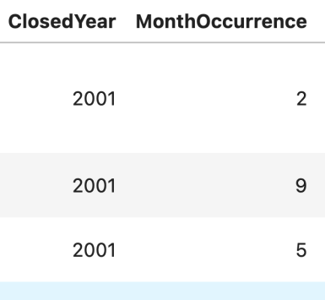

code:
import pandas as pd

df = pd.read_csv(r'~/Desktop/Hate-2001-2023.csv')

df['date'] = df['ClosedYear'].astype(str) + '-' + df['MonthOccurrence'].astype(str)

df

Using these two columns to create a new column “date”:
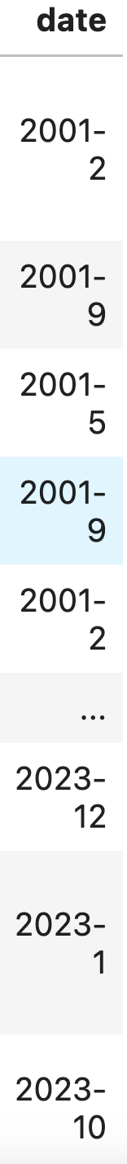

- Generated Records : This report describes what new rows were constructed, how they were constructed, and why…
new record: there are new incidents happened that is why we need to record it.

code:
df.loc[len(df)] = ["A23-0004748344", 2025, 3, 7, 1900, 2, 1, "white", 1, 'Simple Assault',
"Violent Crimes", "Subway", "Anti-White","Race/Ethnicity/Ancestry", "Person",
"Hands", "Verbal slurs", "Unknown", 1, 0, 1, 1, "Not Hispanic or Latino"]

df

Output:
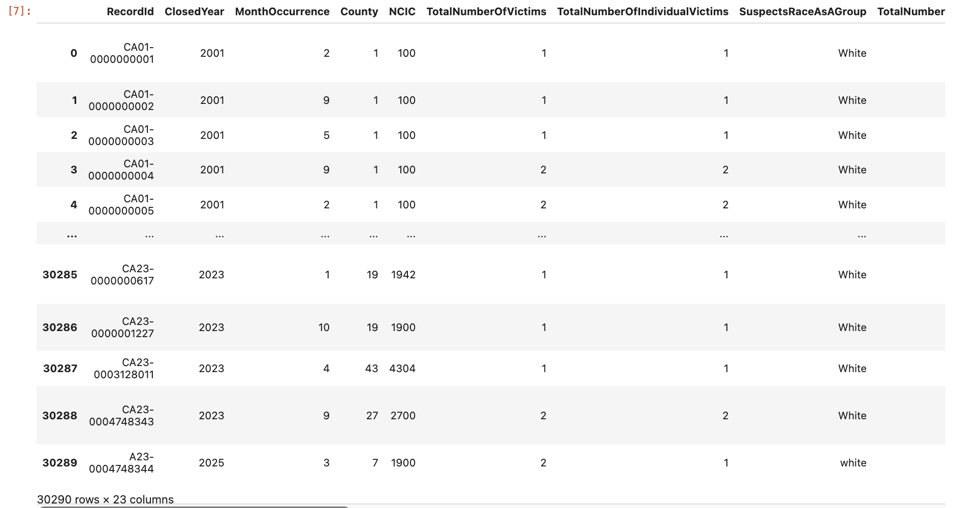

Task 3.4 : Integrating Data…
Deliverable : Merged Data Set…
Two datasets are merged, merged them on year and month, and keep both datasets with ‘outer’, we want to see in the same year and month, what other hate crime are.
Code:
import pandas as pd

df1 = pd.read_csv(r'~/Desktop/Hate-2001-2023.csv')
df2 = pd.read_csv(r'~/Desktop/hate_crimes_datasd.csv')

df1.rename(columns={'ClosedYear': 'year', 'MonthOccurrence': 'month'}, inplace=True)
merged_df = pd.merge(df1, df2, on='year', how='inner')
merged_df.to_csv(r'~/Desktop/mergeYearMonth_inner.csv', index=False)

Task 3.5 : Formatting Data…
Deliverable : Final Formatted Dataset…
- rename and unify columns:
Code:
df = pd.read_csv(r'~/Desktop/mergeYearMonth_inner.csv')
df.rename(columns={'WeaponType': 'weapon', 'motivation': 'MostSeriousBiasType', 'TotalNumberOfSuspects': 'number_of_suspects',
'SuspectsRaceAsAGroup': 'suspect', 'victim_count': 'TotalNumberOfIndividualVictims', 'suspect_race_0': 'SuspectsRaceAsAGroup',
'TotalNumberOfSuspects': 'number_of_suspects', 'crime': 'Offensive_Act'}, inplace=True)
df.to_csv(r'~/Desktop/mergeYearMonth_inner_1.csv', index=False)

- drop columns that are useless
Code:
df = pd.read_csv(r'~/Desktop/mergeYearMonth_inner_1.csv')
df.drop(columns=['month_y', 'suspect_sex_3', 'suspect_race_1', 'suspect_race_2','suspect_race_3', 'victim_sex_3'], inplace=True)
df.to_csv(r'~/Desktop/mergeYearMonth_inner_2.csv', index=False)

- convert year and month column into one column:
Code:
df['date'] = df['year'].astype(str) + '-' + df['month_x'].astype(str)
df.head(3)

- Standardize text column
Code:
df['Offensive_Act'] = df['Offensive_Act'].str.title()
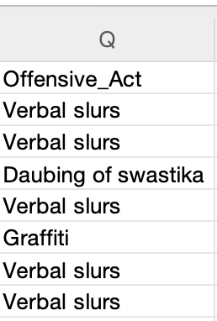 become 